How to setup Tenda FH1202 Dynamic IP mode
Product line: Wireless Model number: FH1202
This article will guide you how to setup Tenda FH1202 Dynamic IP mode and the steps as below.
Note: If you have no idea about what is the internet connection type, please call your ISP to confirm it.
Part 1: Connect the devices
Part 2: Configure your computer
Part 3: Setup the router
Part 4: Check whether you can access internet
- Connect the broadband line with the WAN port of FH1202, and then connect your computer with LAN port of FH1202 by a cable.
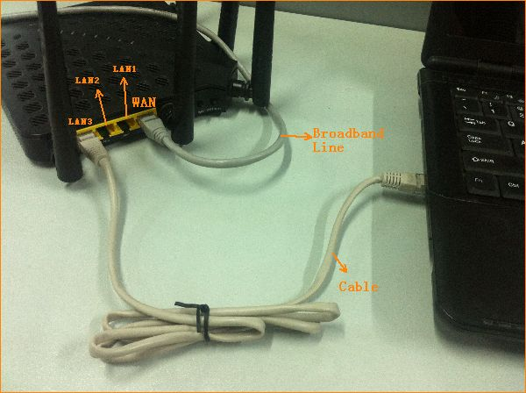
Note: after connection the SYS light should be blinking, the 2.4G and 5G lights should be on or blinking.
1. Click on Network Connection Icon on the system bar, then click on Open Network and Sharing Center.
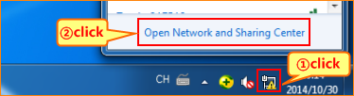
2. Click on Change adapter settings.
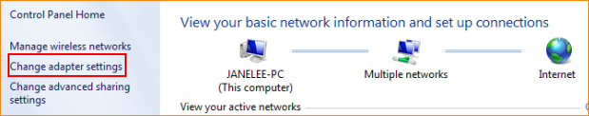
3. Right click on Local Area Connection, then choose the Properties option.
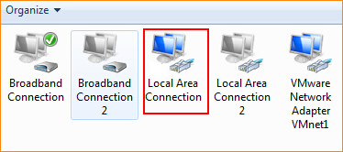
4. Double click on Internet Protocol Version 4(TCP/IPv4).
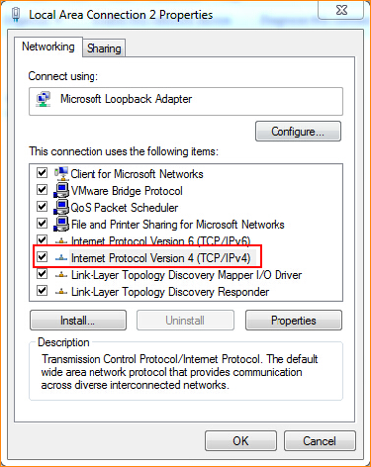
5. Choose Obtain an IP address automatically and Obtain DNS server address automatically and then click OK.
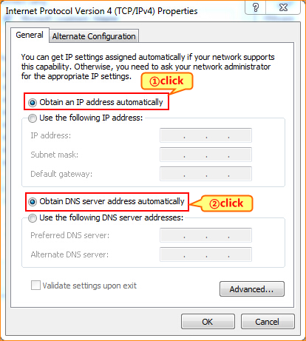
6. Also click on OK on the first Local Connection Properties window.
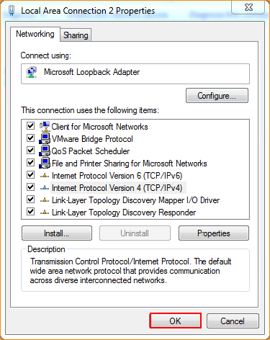
3.1 Setup the router in home page
3.1.1 Open a browser then type 192.168.0.1 in the Address bar, click on Enter.
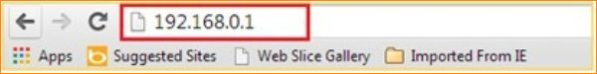
3.1.2 Type the Password as admin in the bars then click on Login to login the setting page of the router.
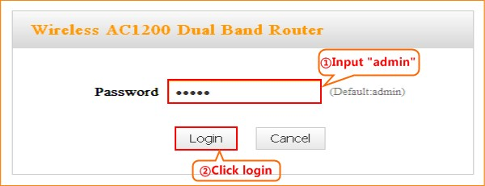
3.1.3 Choose the Dynamic IP option, then set a 2.4G Security/5G for the wireless security , then select High or Medium or Low for TX Power, then click on Save to save the settings, then click on Advanced.
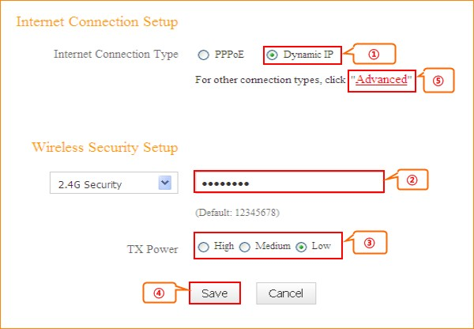
3.1.4 After setting, please click on Tools, and click on Reboot then hit on the Reboot button to reboot the router for refreshing the device info.
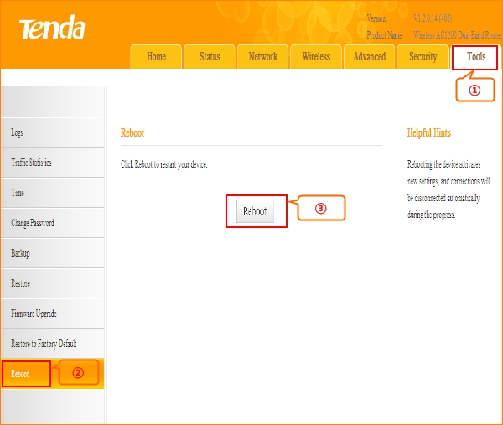 4.1 Click on Advanced to login the advanced setting page, then check the WAN Status if the Connection Status shows Connected that means you can access internet, please check.
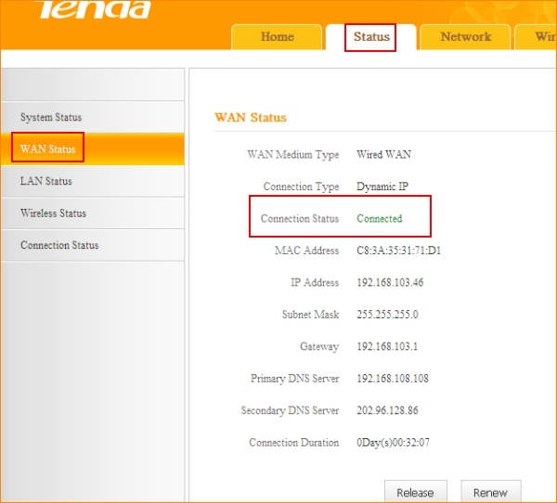
4.2 If you can’t, please click here and follow the steps below.

4.2.1 When the Connection Status show Disconnected, it means that there are some problem with the WAN Connection. please check hardware connection.
4.2.2 When the Connection Status Show Connecting, please try the steps as below:
A: Click Network——MAC Clone——Clone MAC to clone your computer’s MAC address to the router’s WAN port, then click Save to save the setting and click Reboot.
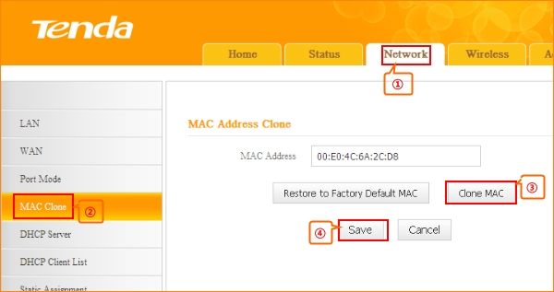
B: Click Network——LAN——IP address, change it to 192.168.10.1, click Save to save the setting and the router will reboot automatically.
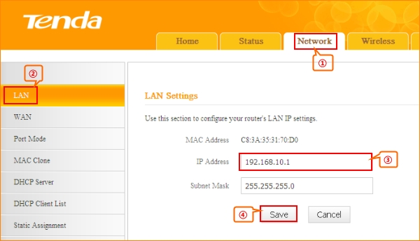
C: If the Connection Status is still Connecting, please reboot the modem and router together.

